Present | Past
should do | should have done
must be
can’t work
might know
could be sick
may not know

Use past modals to speculate about the possible reasons:
- Hector has a suntan.
may __________________________________________________________________
must __________________________________________________________________
might __________________________________________________________________

- Your phone isn’t in your bag.
could __________________________________________________________________
must not __________________________________________________________________
might __________________________________________________________________

- You texted your friend but they haven’t replied.
can’t __________________________________________________________________
might __________________________________________________________________
may __________________________________________________________________

- You hear a loud bang outside.
must__________________________________________________________________
could__________________________________________________________________
might__________________________________________________________________

- Your friend fails her exam.
may not__________________________________________________________________
can’t__________________________________________________________________
might_________________________________________________________________
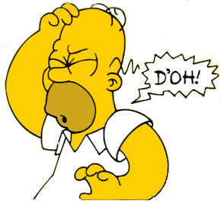

Listen to the song by Beverley Knight
- Which past modal verbs can you hear?
- What mistake did she make?
- Complete the sentences with the past modal verbs:
………………………………………………. spent more time with her boyfriend.
………………………………………………… made different choices in her life.
…………………………………………….talked to him but she was too busy.
What should they have done?
1.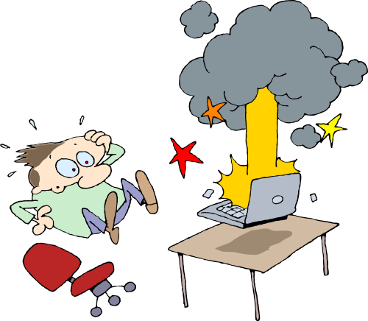 2.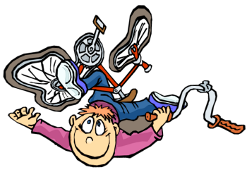 3. 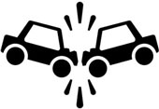 4. 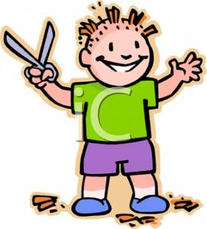
5.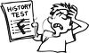 6.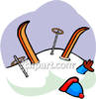 7. 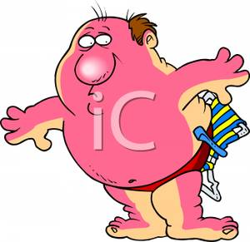 8. 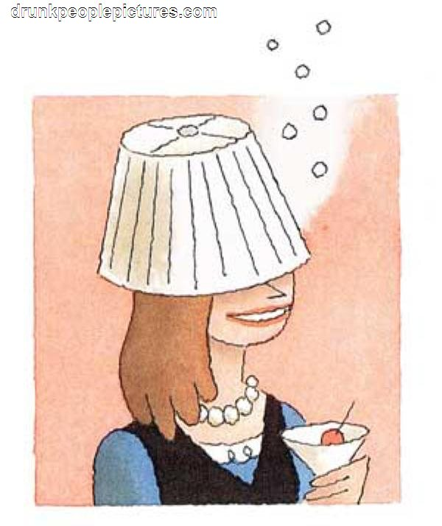

Think of a time where something didn’t go well for you. Say what went wrong/ what you should have done but didn’t.
e.g. I didn’t prepare my Trinity topic. I would have started earlier but I had to study for my exams at school.
e.g. I worked as a tax advisor for 6 years. I should have become an engineer
e.g . I failed my exam. I could have studied harder.

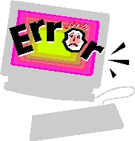

Lyrics to Shoulda Woulda Coulda, Beverley Knight

People said that together we were both sides of the same coin
And we would shine like Venus in a clear night sky
We thought our love could overcome the circumstances
And my ambition wouldn't allow for compromise
I could see in the distance all the dreams that we didn't mean
And every choice I had to make left you on your own
Somehow the road we started down had split asunder
Too late to realise how far apart we'd grown
And how I wish I (wish I)
Wish I'd done a little bit more
Now shoulda, woulda coulda means I'm outta time (I'm outta time)
Shoulda, woulda, coulda can't change your mind
And I wonder (wonder)
Whatta, what I'm gonna do
Shoulda, woulda, coulda are the last words of a fool
People ask what it feels like to live the kinda life others dream about
I tell them everybody gotta face their highs and their lows
And in my life there's a love that I put aside
'Cos I was busy loving something else
And so for every little thing that you hold onto
You gotta let something else go
How I wish I (wish I)
Wish I'd done a little bit more
Now shoulda, woulda coulda means I'm outta time (I'm outta time)
Shoulda, woulda, coulda can't change your mind
And I wonder (said I wonder)
Whatta, what I'm gonna do (and I wonder, wonder, wonder)
Shoulda, woulda, coulda are the last words of a fool
If I would not forsake
The opportunities of fate
I know I'm right where I belong
But sometimes when I'm not that strong...
I wish I (wish I)
Wish I'd done a little bit more (and I wanna, shoulda, woulda, shoulda, coulda)
Now shoulda, woulda coulda means I'm outta time (oh I'm outta time)
Shoulda, woulda, coulda can't change your mind
And I wonder (said I wonder) Whatta, what I'm gonna do (oh oh-oh-oh)
Shoulda, woulda, coulda are the last words of a fool
And how I wish I
Wish I'd done a little bit more
Now shoulda, woulda coulda means I'm outta time
Shoulda, woulda, coulda can't change your mind
And I wonder (Shoulda, woulda, coulda means I'm out of time)
Whatta, what I'm gonna do (Shoulda, woulda, coulda can't change your mind)
Shoulda, woulda, coulda means I'm out of time
Shoulda, woulda, coulda can't change your mind
Can't change your mind

Answers
Use past modals to speculate about the possible reasons:
- He may have been on holiday. He must have been sunbathing. He might have been sitting in the garden.
- Someone could have stolen it. I must not have put it in my bag. I might have left it in the kitchen.
- He can’t have seen the message. He might have left his phone at home. He may have been ignoring me.
- It must have been a firework. It could have been a car crash. Someone might have fired a gun.
- May not have had time to study. She can’t have studied hard enough. She might have had a bad day.

Song
She should have spent more time with her boyfriend.
She could have made different choices in her life.
She would have spoken to him but she was too busy.

What should they have done?
1. | He could have spent less time surfing the net.  He should have bought a better computer.  He would have bought a better computer if he’d had more money.
2. | He should have worn a cycle helmet.  He could caught the bus instead of cycling.  He wouldn’t have crashed if he’d cycled more carefully.
3. | They shouldn’t have driven in the snow.  They could have driven more carefully.  If they’d known they were going to crash they wouldn’t have left the house.
4. | His parents should have hidden the scissors.  He could have gone to the hairdresser instead.  If he hadn’t been bored he wouldn’t have cut his own hair.
5. | He could have studied more.  He shouldn’t have partied so much before the exams.  If he’d had more time he would have revised.
6. | He could have gone on a beach holiday instead.  He should have been more careful.  He wouldn’t have had the accident if he’d stayed on the easy runs.
7. | He could have used sun-cream.  He shouldn’t have spent so much time in the sun.  He wouldn’t have gotten so burnt if he’d stayed in the shade.
8. | She shouldn’t have drunk so much.  She could have drunk lemonade instead.  She’d had more self control she would have gotten so drunk.

